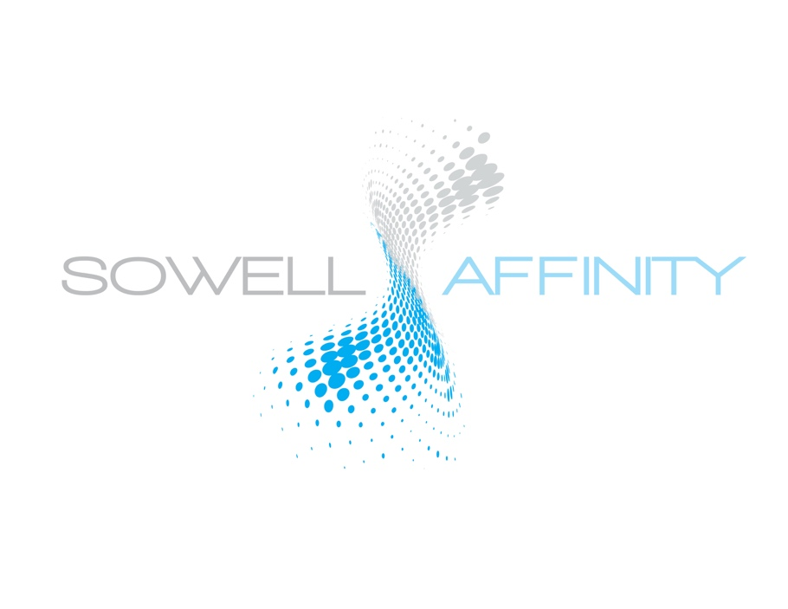

FOR IMMEDIATE RELEASE

Erin Taylor, Sowell Management
Director, Marketing & Communications
501-333-6688o / 501-813-7155c
erin@sowellmanagement.com

Sowell Management Announces Partnership with
Affinity Investment Advisors, Launching New OCIO Services and Expanded Portfolio Management Platforms

LITTLE ROCK, AR, April 2020 – Sowell Management has selected Affinity Investment Advisors to partner in launching their Outsourced Chief Investment Officer service for financial advisors. In addition, Affinity will begin managing the day-to-day portfolio management responsibilities for the firm. The combined companies have approximately $4 billion in affiliated assets.

Bill Sowell, CEO and founder of Sowell Management, and Greg Lai, CFA, Principal and Lead Portfolio Manager for Affinity Investment Advisors have been working diligently since early 2019 to bring together this key strategic partnership. Sowell Management has been a pioneer as a fee-based fiduciary since 1995, offering a full breadth of service solutions to financial advisors nationwide, with a key offering being portfolio management through its TAMP offering. This strategic partnership brings new opportunities and enhanced offerings.

“Given the depth of experience, the Affinity team brings to Sowell,” said Bill Sowell, “it’s certainly a substantial benefit to our advisors. As a percentage, I’m not sure I’ve ever seen a firm with more CFA’s and MBA’s. They have a remarkable breadth of industry knowledge, and forefront thought leadership. But this is actually secondary to their culture and intrinsic core values. I’ve gotten to know and work with the Affinity team, and our cultures couldn’t be more similar. That’s a considerable part of what makes this partnership work.”

Sowell Management has been offering TAMP services for more than 20 years. The addition of Affinity was a natural progression and evolution in expanding these services, as well as launching the OCIO services. The new OCIO services allow advisors to manage client relationships while adding to their team some of the brightest minds in the industry in constructing portfolio themes along with tax-managed strategies. “We are thrilled to partner with such a high quality, experienced provider of services to the RIA community,” said Greg Lai,with Affinity. “We are honored and embrace the immense responsibility that Bill and his team have given us. The future is bright, and I can’t imagine a better partner to work with.”

With Sowell Management being based out of Little Rock, AR and Affinity based out of Newport Beach, CA, this partnership provides Sowell with a stronger West Coast presence, helping to continue uplifting its phenomenal growth. With more than 50 branch offices in approximately 30 states (and more than 200 advisors), Sowell Management already has a large concentration of advisors on the west coast, so adding 10 investment professionals to the existing Investment Management team will help support and facilitate these TAMP services to our advisors.

Alex Hsiao, Chief Operating Officer and Senior Director of Client Engagement at Affinity, will lead the firm's development of the TAMP platform and OCIO services. In addition to the existing portfolios developed by Sowell and Affinity, the platform will offer portfolios of other institutional managers that you won’t find at most wirehouses and other “big box” firms. With more than 30 years’ experience, Alex’s expertise is in early-stage investing, dynamic asset allocation, building diversified investment portfolios, and providing outsourced customized solutions and product development that will provide Sowell advisors tailored solutions.

“We are always looking to the future”, emphasizes Sowell. “It’s the promise of a better tomorrow that makes us strive to be even stronger today. As we think about our role in the growing RIA industry, we look to be visionaries and leaders, and with the addition of the Affinity team, we keep moving to support our advisors in the right direction.”

###

About Sowell Management.
Sowell Management is a privately held Registered Investment Advisor (RIA), providing financial advisors with an established path and suite of customized solutions – enabling advisors to be in business for themselves but not by themselves. A pioneer as a fee-based fiduciary since 1995, Sowell has affiliated assets close to $4B. Headquartered in North Little Rock, Arkansas, with advisors nationwide, Sowell embraces a core-value culture that drives who they are as a company and as people. Learn more at www.sowellmanagement.com.

About Affinity Investment Advisors, LLC.
Affinity Investment Advisors, LLC is a boutique investment advisory firm based in Newport Beach, CA. Driven by a passion to be our clients’ most trusted equity investment manager, the company offers a diverse product suite focused on maximizing financial returns for the long-term investor. Affinity’s client base is a mix of institutional and retail, and the firm serves its retail clients through advisory relationships with nationally recognized firms. Learn more at www.affinityinvestment.com

